ALWARD PARENTS,

Would you like to have an EAGLES S.O.A.R. shirt this year?
The Walk-a-Thon committee will be selling t-shirts this year. The theme for Walk-a-Thon this year is EAGLE PRIDE so order your shirt and come out to cheer on your child on Walk-a-Thon day!
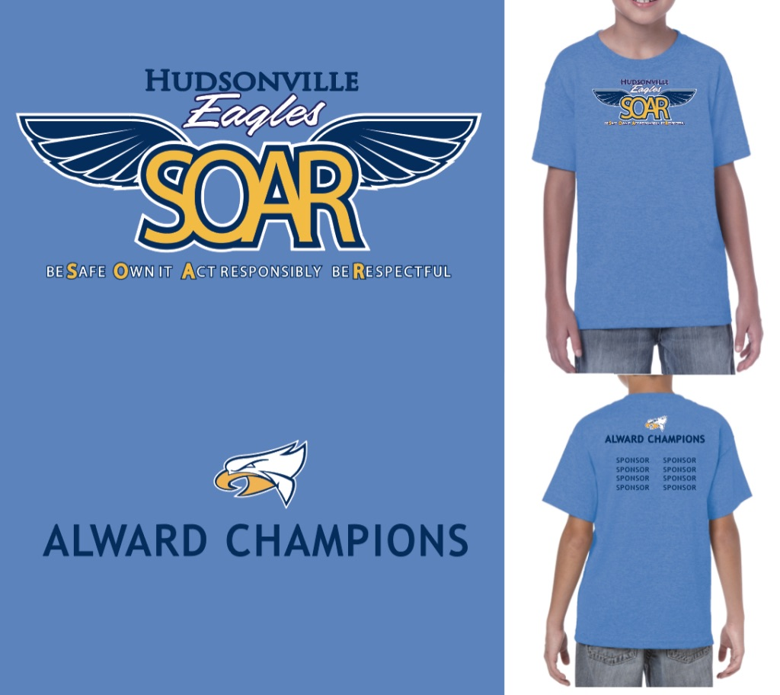

Front of Shirt

Back of Shirt

Prices for T-Shirts
Adults XS-XL- $10.00
Adult 2X - $12.00
Adult 3X - $14.00

All Alward students will receive a shirt the day of walkathon. Please DO NOT order a shirt for an Alward Student. If you would like to order for a sibling prices are below.

Kids XS-XL- $10.00

All orders and money are due by THURSDAY, Sept 12th. NO EXCEPTIONS!!!

Shirt Size | Quantity | Total

Total Amount for Order: _$___________________
Please make checks payable to Alward Elementary PTC

Parent Name: _________________________________________________

Student Name: _________________________________________

Teacher Name: _________________________________________

